ATL SKILLS FOR A POST-COVID DIGITAL WORLD

DAY 1

Lance G. King

lance@taolearn.com
www.taolearn.com
Lance King

ATL SKILLS FOR A POST-COVID DIGITAL WORLD

Positives of the pandemic:
- 20% of students improved their academic performance
- All were great self-managed learners – with all the skills for success in the post-Covid digital world

By 2030:
- Automated cars, buses, taxis, trains, aircraft, food delivery, doctor’s visits, banking, law, most retail
- Artificial Intelligence involved in all aspects of life
- Most employees will be freelance – contracted into on-line collaborative teams working on specific projects
- Selection for employment in work teams will be based on skills and experience and driven by Social Media
- Social Media identity will be as important as real-life identity
- Highest paid skills will be research, analysis, finding the truth, predicting trends, adapting, creating and problem solving

“The world economy no longer rewards people just for what they know, the world economy rewards people for what they can do with what they know” - Andreas Schleicher, PISA, OECD

PISA 2025 will include the innovative domain of Learning in the Digital World which aims to measure students’ ability to engage in self-regulated learning while using digital tools.

Kazakhstan National Curriculum Categories of 21st C Skills | ATL Skills - Sub-Categories
COMMUNICATION SKILLS | - Language skills
 | - Social Skills
PROBLEM SOLVING and DECISION MAKING | - Organization Skills
 | - Decision Making Skills
TEAMWORK and INDIVIDUAL WORK SKILLS | - Metacognitive Skills
 | - Character Skills
 | - Group Skills
 | - Study Skills
RESEARCH SKILLS | - Research Skills
 | - Media Skills
ICT SKILLS | - Computational Thinking Skills
CRITICAL THINKING SKILLS | - Critical Thinking Skills
CREATIVE APPLICATION OF KNOWLEDGE | - Idea generation Skills
 | - Adaptive thinking Skills

Purpose of any ATL skills programme:
- To develop self-managed learners:
  - by teaching all students a full curriculum of ATL skills
  - by having students use their ATL skills to improve their academic performance in all their school subjects
  - by giving students increasing practice in the management of their own learning from Gd 1-12
- To help students realise that they do have control over their own success at school and beyond

Any ATL skills programme is all about focusing students on factors to improve their success that are in their control.

Three key phases of ATL skill proficiency development:
- Competence - student copies skill and learns ‘how best’ to use the skill with simple content
- Practice - Student then practices using the skill with subject content of increasing complexity and works towards being able to use the skill whenever needed
- Mastery - Student can use the skill independently of the teacher and the classroom

Task 2: Mapping learning challenges
- Get into 12 (or 13) grade level groups
- Each group - discuss what are the most important learning challenges for students in your year – consider both transition and assessment challenges
- Put all the learning challenges into a priority order
- Decide on your top three
- Write your Grade level on one A1 page
- Write your top three learning challenges on your page and pin it on the wall – in sequence

Task 3: Mapping ATL skills to meet learning challenges
- Get out of grade level groups, get into pairs with a friend, take a learning walk, read what is on each page, look across all the 12 pages and look for repetition. For any repetition try to get more specific about the challenge in each year.
- Pick any grade level, look at what is written and discuss what the specific ATL skills would be that would help a student to succeed in the particular learning challenge facing them in that year.
- Think about when a student would need to learn that particular ATL skill in order to be ready to use it when needed
- Write the ATL skill strand on a Post-it note and stick it on the appropriate grade page – when it needs to be learned.
- Repeat
- Be very precise about exactly what skills are needed – exactly what does a student need to know how to do to succeed in each learning challenge?

Task 4: Mapping ATL skills to meet learning challenges
- Take another learning walk, look across all pages, find any duplications of skills, leave the earliest mention remove any subsequent duplicates
- Get back into your 12 grade level groups, take your page off the wall
- Analyse all the Post-it notes on your page, eliminate duplication
- Decide on the Top Ten ATL skills for your grade
- Write them on the page, put the page back on the wall
- Look across grades for duplication, leave the earliest mention cross out the subsequent ones
- Now you have the beginnings of a plan, next step is to decide:
  - Who, when, where & how?

Two steps to teaching ATL skills:
- Explicit Teaching:
- Designing whole lessons or parts of lessons to specifically teach ATL skill strands
- Developing ATL skill strand Competence using simple content
- Implicit Teaching:
  - Having students Practice their ATL skills in inquiry-based subject lessons
  - Developing and improving ATL skill competence up to Mastery level by using them with subject content in subject lessons

Where will the time come from?
- Developing student Competence in the ATL skills they need takes teaching time – where will this come from?
  - Self-teaching online ATL modules
  - Self-teaching ATL textbooks
  - Within existing classroom time
  - Outside existing classroom time
  - Set up a volunteer student study club
    - CAS project?

Part 1 – Explicit teaching of ATL skills:
- What if – every student from Gd5/6 had a one-hour/week ‘Learning Skills’ lesson in their timetable?
  - The Learning Skills program could be aligned with student development so all students develop Competence in all the cognitive, metacognitive, social and emotional (ATL ) skills they need when they need them
  - The purpose of the Learning Skills lessons would be for students to learn ‘how best’ to use each ATL skill
  - Each student learns the ATL skills they need at the time, to cope with the learning, social and emotional challenges they face

Part 2 – Implicit teaching of ATL skills:
- Then students could practice and improve their ATL skills in normal subject lessons.
  - Teachers can feel confident that students will already have some competence in all the ATL skills they need to cope with the learning challenges in the classroom
  - Teachers will feel encouraged to use more inquiry-based teaching, problem-based teaching, experiential learning, independent and remote learning
  - Students will be more successful in learning all their normal subjects using these methods
  - Students will master all the ATL skills they need for their future education, job, career and business success

Task 5: Mapping the development of skill Competence
- Stay in your 12 grade level groups, work in pairs, pick one ATL skill from your Grade level page to work on together
- Do your research, find out how other people practice, coach or “teach” your particular ATL skill strand
- Design one generic exercise any teacher could use to introduce the skill to the students for the first time using any content to develop Competence
- Then design one exercise you could use to have students Practice this skill in one of your subject classes
- Write the skill and both exercises into your subject spreadsheet

Eg. Competence exercise for Gd11 – How to conduct ‘Advanced Searching’ online?
- Work with a partner
- Find two Advanced Searching tutorials from reputable search engines and watch one each – make sure they are tutorials relating to different search engines
- As you watch pause the feed after each key point and write the key point in the table below
- When you have finished compare notes and write your partners key points in your table too
Search Engine …………………………………………..
Tutorial URL ……………………………………………..
Key points ………………………………………………...
- Make sure you use some of these search reduction techniques in every search from now on

To develop self-managed learners:
- Teachers must learn how to limit ‘teaching’ and allow self-managed learning to take place
- Only by being allowed to practice the skills of self-managed learning will students become effective self-managed learners

Social media skills:
In communicating feelings and attitudes we take:
- 7% from the words
- 38% from the tone of voice
- 55% from the face and body - Albert Mehrabian (1967)

By the time they are 10 all students need to learn how to:
- Identify their own virtues and values, who they are as a person off-line and who they want to be
- Identify the difference between reputation and character, their real vs online persona
- Create an online identity focused on strengths, goals and exemplifying their virtues
- Find positive, inspirational people to follow
- Make ethical choices about “likes”
- Set up and maintain strong relationships that exist both on and off line
- Have regular, deliberate, digital holidays

Task 6 – Your analogue self:

Task 7: Influences and influencers

Metacognitive skills – reflection, thinking about thinking, learning about learning
- Metacognitive Knowledge – students noticing and learning how they are learning - the thinking and learning strategies, techniques and skills they use to achieve successful learning
- Metacognitive Performance – students using that knowledge to improve their learning performance, change ineffective strategies, try new techniques, learn new skills
  - The key to metacognition is noticing your own thinking

Task 8: Developing Metacognitive Knowledge using Think-Alouds:
- The ‘Student’ – is working on the puzzle and is allowing all their internal dialogue to be audible, they are saying out loud every word and every thought that is coming into their mind
- The ‘Teacher’ - is not working on the puzzle, just listening carefully to the ‘student’ and encouraging them to keep continuously talking - by saying things like “keep talking, keep talking…” and by asking questions:
  - questions which ask the student what they are thinking, what are the difficulties they are having with the puzzle and how they are going to overcome them
  - questions which focus on the thinking process NOT on the solution to the puzzle
  - THE ‘TEACHER’ MUST NOT HELP THE ‘STUDENT’ FIND THE ANSWER

Task 9: Developing metacognitive knowledge through reflection on process
- In those exercises, when you got ‘stuck’ -
  - describe to your partner what you said to yourself
  - describe what you imagined
  - describe what you did to move past a ‘stuck’ moment
- That is your problem-solving process for visual puzzles
- Teach it to your students

Using assessment of understanding to develop metacognitive skills:
- At the end of any unit of work
  - Have they achieved the content and process goals?
  - What is their evidence?
    - Is this really what you as a teacher need to know?
  - What don’t they understand yet?
  - What questions do they have?
- This turns assessment into metacognitive training – recognising gaps in knowledge and understanding.
- Teaching students how to notice what they don’t yet know is far more useful than having them prove what they do know

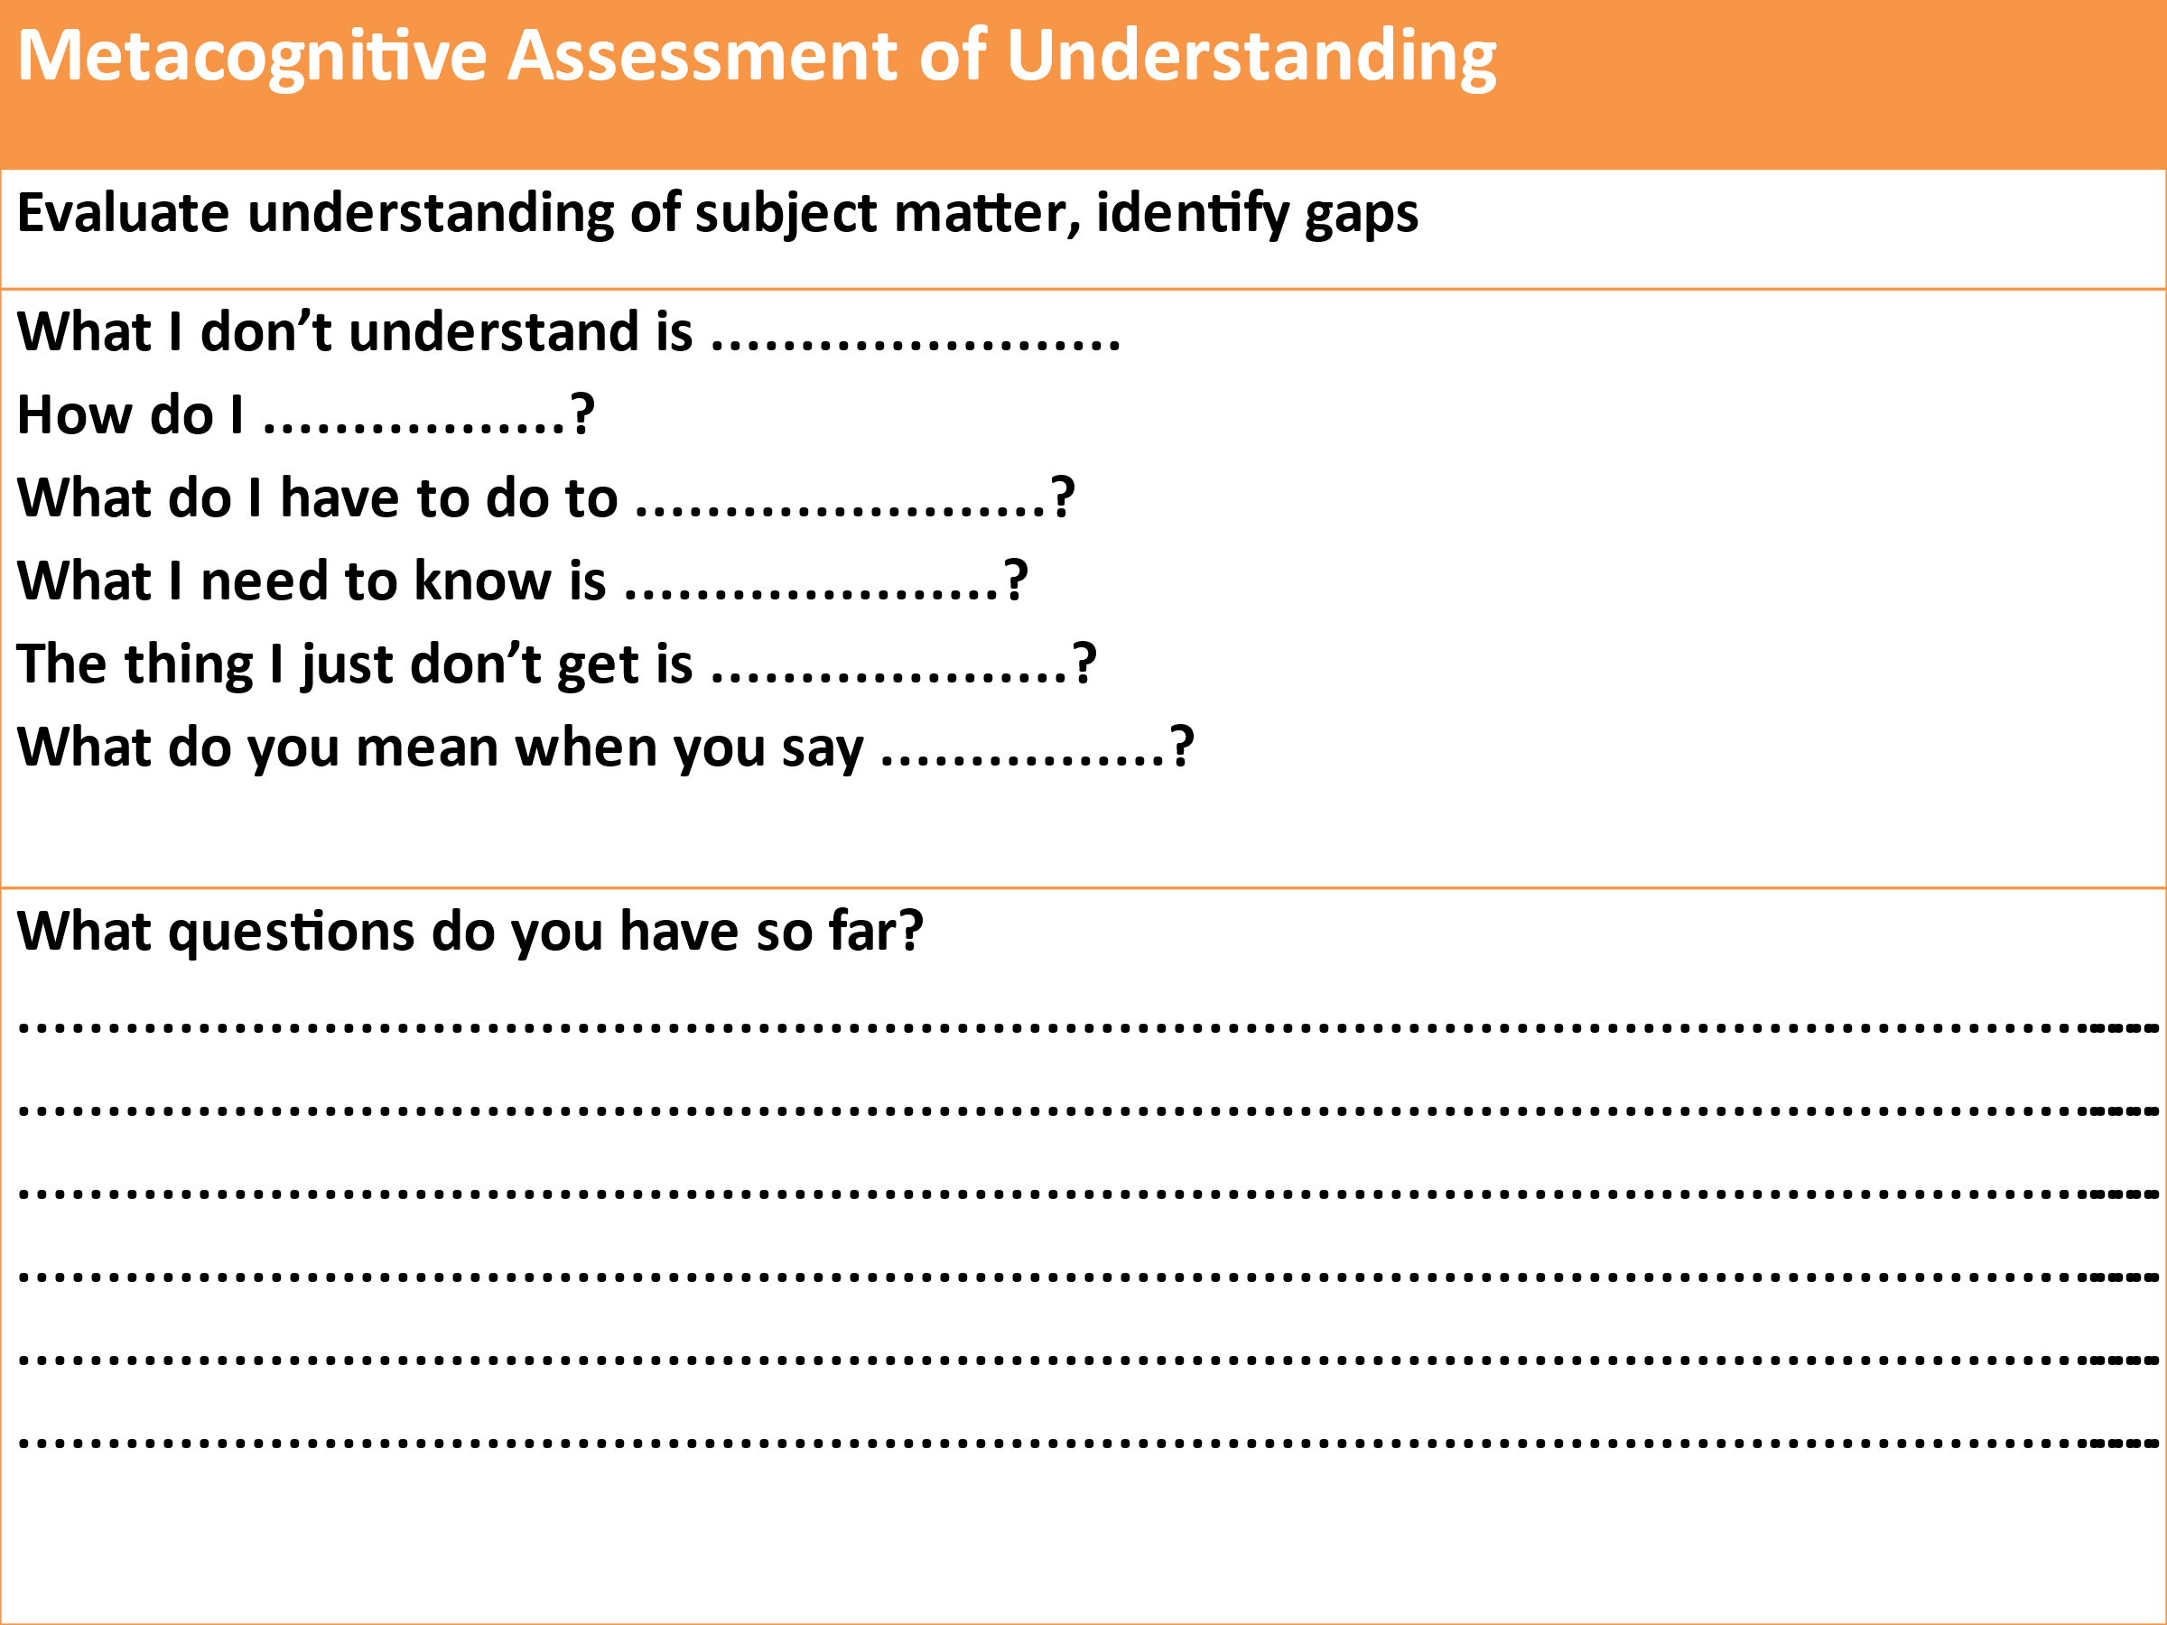

Assessing ATL skills:
- When your ATL programme is working well you will see:
- improvements in the efficiency and effectiveness of your students learning in all their normal subjects
- improvements in their performance in formative and summative assessments and all high-stakes exams, and
- improvements in in their ability to manage their own learning

Using ATL skills self-assessment to develop metacognition:
- Learning how to accurately self-assess your own work is a ATL skill in itself
  - get students to self-assess their own ATL skill development
    - for this you first need Mastery statements for all ATL skills
    - then you need one development rubric to cover all ATL skills

Task 10: ATL skill Mastery
- Someone add a Mastery column to each spreadsheet
- ‘Mastery’ is the highest standard of independent use of that skill that you would expect to see at school – by the end of Grade 12, with no teacher support:
- “By the time our students finish at this school they will be able to ………………………...”
- Take your particular ATL skill from the previous mapping exercise and create a mastery statement for that skill
- Add your mastery statement to the spreadsheet

Rubric for all ATL skill development and assessment:
Competence |  |  | Practice |  |  |  | Mastery
Watching | Copying | Starting |  | Practising | Getting better | Got it! | Teaching
I know what the use of the skill looks like when others are using it | I can copy someone else using the skill | I am starting to use the skill by myself |  | I am using the skill by myself in familiar situations | I am getting better at using the skill in unfamiliar situations | I am able to use the learning skill whenever I need to | I use the skill without needing to think it through first
I can break the skill down into steps | I use the skill one step at a time | I am still conscious of using the skill one step at a time |  | I am starting to put all the steps of the skill together | I can usually use the skill without referring to the way that I have done it in the past. | I can confidently use the skill without referring to the way that I have done it before | I am capable of teaching other students how to use the skill
When I try to use the skill myself I make lots of mistakes and ask lots of questions | I still make mistakes and ask for help but I am getting better at correcting my own mistakes | I can correct my mistakes with some help |  | I can correct my own mistakes | Any mistakes I make I can quickly correct | I can usually correct any mistakes automatically | I correct any mistakes I make automatically
I need lots of help to use the skill | I can use the skill in familiar situations with some help | I still need help to use the skill sometimes |  | I don’t need help to use the skill in familiar situations anymore | I still need help to use the skill in unfamiliar situations sometimes | I hardly ever need help to use the skill anymore | I can use the skill in unfamiliar situations without any help from anyone else

Student self-assessment of ATL skill development:
Student Self-Assessment of ATL Skill Proficiency
ATL Skill | Competence |  | Practice |  |  |  | Mastery
 | Watching | Copying | Starting | Practising | Getting better | Got it! | Teaching

Developing self-assessment as an ATL skill in itself:
- Use self-assessment to teach students how to accurately judge the quality of their own output - the most important ATL skill for all future education and careers
- When assessing students’ subject work try:
  - asking them to include a self-assessment on what they did well and what they could improve on
  - give them feedback on both their subject work and the quality of their self-assessment

Three valid forms of ATL skills assessment:
- Student self-assessment of ATL skills proficiency completed pre~ and regularly post~ training
- Teacher reporting on ATL skills in reports – qualitative not quantitative
- Designing subject-based assessments so that generating the answers needed requires the use of specific ATL skills at the appropriate level of proficiency

DAY 2

Affective ATL skills – developing character and promoting mental health:

Students first need to understand that learning starts with belief

Efficacy + Agency + Action

1) Efficacy they must first believe that they can achieve success through their own actions
- Role models - stories of resilience, perseverance, innovation, effort and most importantly - learning
  - Alumni – display your school’s success stories, detail their skills
  - Visiting speakers – to talk to your students about what it takes to be successful
  - Own stories – tell your students your own stories of learning success
- Self-esteem – valuing children for their character more than their behaviour
  - Connect positive comments to ‘being’ – “you are a conscientious, hard working person”
  - Connect negative comments to ‘doing’ – “you need to organize yourself better”
- Watch your language
  - Eliminate the don’ts
  - Focus on the do’s

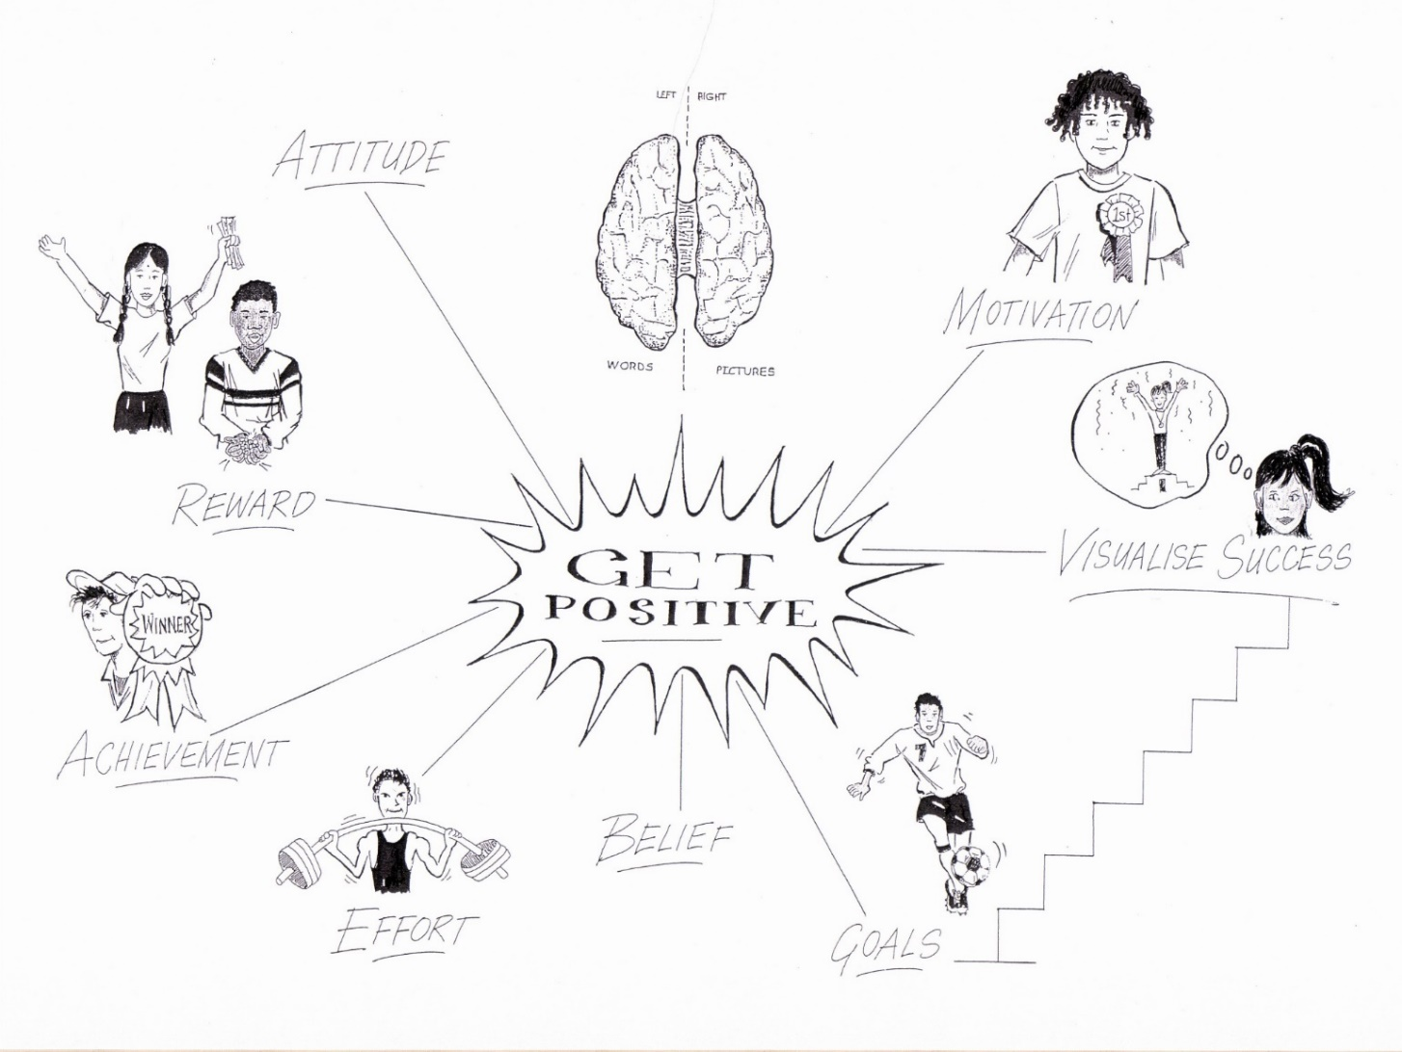
2) Agency they must learn all the ATL skills they need for education and career success
- Identify your students’ major learning challenges in each year
- Identify the ATL skills that would help students to succeed in each learning challenge
- Explicitly teach your students the ATL skills they need before they need to use them
- Once they have achieved Competence, make sure they practice and develop their ATL skills in subject lessons

3) Action they must be prepared to take action, make mistakes and fail well

Task 1: Success and Failure: | What happened? | What do you think was the cause of your success or failure? | What did you do next?
A time when you set a goal and achieved it was …
A time when you set a goal and didn’t achieve it was…

"All the top academic students had learned how to fail well
whereas all the lowest academic students were failing badly"

Reactions to failure
Failing Well | Failing Badly
- Acknowledge your failure,  - take responsibility for all the factors that were in your control  - work out what you could have done better  - make changes, and  - do it again, and again if necessary  - but do it differently, every time | - Blame the school or the ‘system’  - Blame other people  - Pretend there is no failure  - Add ‘drama’ to failure to avoid dealing with it  - Avoid any activity that could possibly lead to failure
Full article available at www.taolearn.com/wp-content/uploads/articles/article88.pdf
On receiving test results worse that they expected (or hoped for) some students will
Fail badly - blame the school, the teacher, the weather, their own character
Fail well - rewrite the answers to all the questions they got wrong
  - check back with you to make sure they have got the right answers now
  - ask you what they can do to improve
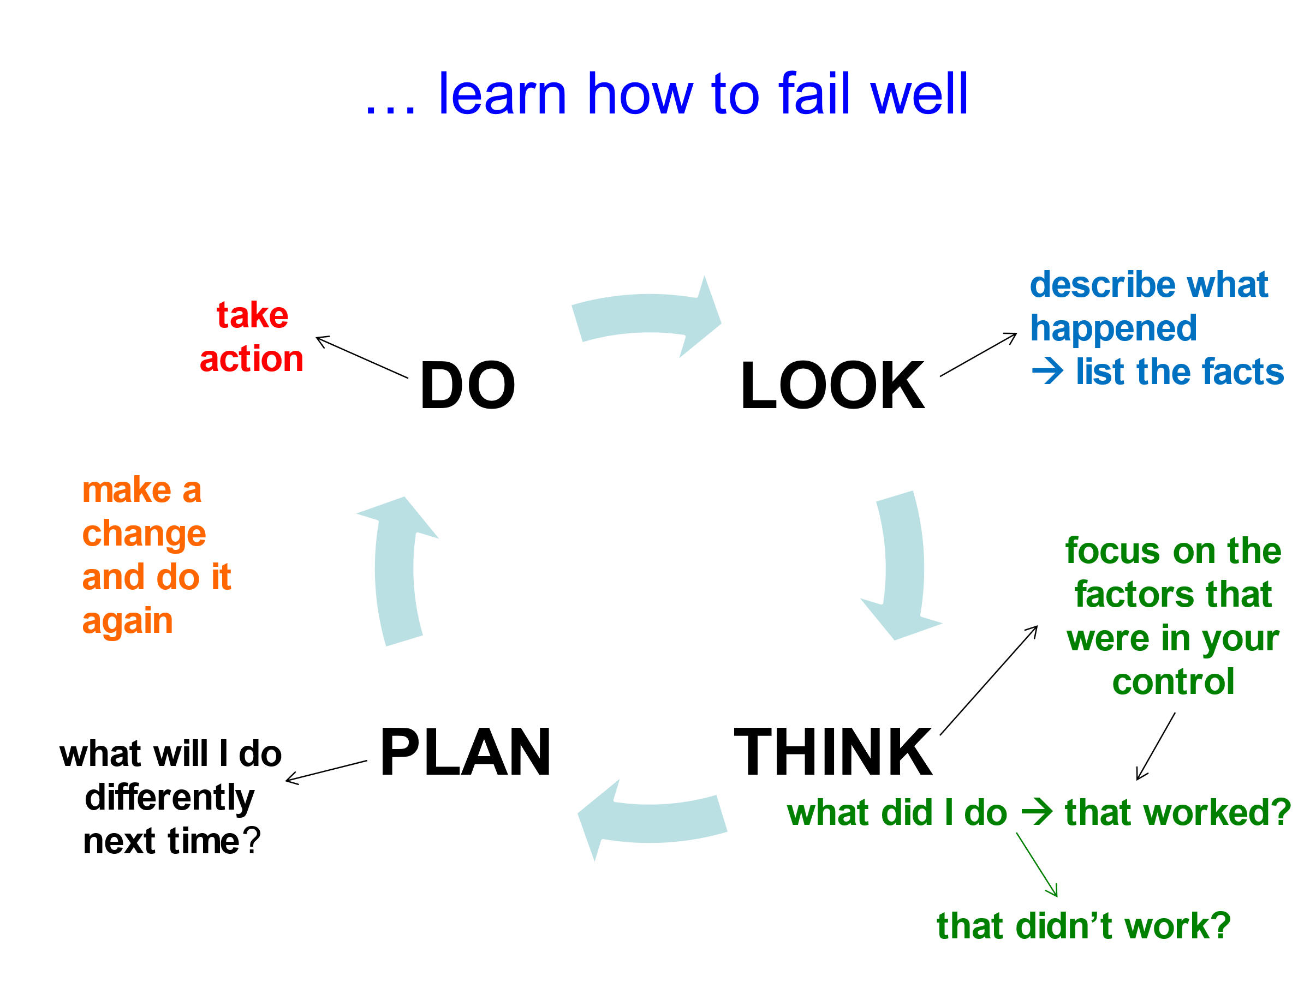

Helping students learn how to fail well
1. Before any assessment - get students to set their own goals for the outcome
2. After the assessment - have a conversation about the difference between failing well and failing badly
- Teach your students how to fail well
- Build in class time for the re-processing of every mistake

Competition and the skills of high performance:
- Stay in the moment – “What is happening right here, right now?”
- Engage your students with subject-based activities that require deep concentration e.g. reading
- Support them in achieving a PB – in everything
- Encourage them to take on new challenges and use any failure as feedback
- Avoid judgement
- Teach students how to accurately judge the quality of their own output - the most important ATL skill for all future education and careers
- When assessing students’ subject work try:
  - asking them to include a self-assessment on what they did well and what they could improve on
  - giving them feedback on both their subject work and the quality of their self-assessment
- Control what you can control

Prof Carol Dweck on Attribution for Success and Failure
Attributing to effort ….  “my hard work, persistence, determination…”  - Is linking your success and failure to something over which you have control  - Any test or assessment becomes a measure of progress, an opportunity to learn | Attributing to ability ….  “my talent, intelligence, natural ability….”  - Is linking your success and failure to something over which you have no control  - assessment is then often seen as a critical judgment and an opportunity to fail

Ways of Thinking
Verbal | Non-Verbal
- words  - logic  - ‘one step at a time’ thinking  - self-talk  - analysing  - phonetic memory  - detail first | - pictures  - guesses  - ‘all at once’ thinking  - imagination  - synthesising  - visual memory  - big picture first
Turning those ideas into reality | Generating ideas that don’t yet exist
Good problem solving requires both ways of thinking

Task 4: Patterns in Maths:
Use the number chart to find the pattern and then add some more numbers to the series:
1, 3, 5, 7, 11, 13 ……………………………………………………………………………………………………………
4, 22, 26, 34, 38 ……………………………………………………………………………………………………………
9, 33, 39, 51 …………………………………………………………………………………………………………………
5, 25, 55 ………………………………………………………………………………………………………………………
16, 20, 28, 32 ………………………………………………………………………………………………………………
12, 18, 30, 40 ………………………………………………………………………………………………………………
24, 36, 48, 60 ………………………………………………………………………………………………………………
What’s special about;
60? ………………………………………………………………………………………………………………………………
72? ………………………………………………………………………………………………………………………………
VAK and ‘learning style’
learn by: | thinking in: | style:
looking | pictures | Visual (V)
listening and talking | sounds | Auditory (A)
doing | feelings | Kinesthetic (K)

VAK Teaching Strategies:
Visual: use video, film, photographs, use colour on the board, notes, highlighting key points in text, pictures, posters, diagrams and graphs, using mindmaps, using visualisation, using gestures, facial expressions, creating flowcharts of processes, video-based websites eg YouTube

Auditory: reading out loud, playing podcasts, playing quiet instrumental music, talking, describing, dictation, creating discussions or debates, using word games, puns, jokes, asking and answering questions, telling stories, myths, using metaphors, formal and impromptu speeches, inviting in guest speakers, Audio-based websites e.g. Khan Academy

Kinesthetic: having the experience, VR & AR, 3D modelling, allowing moving, stretch breaks, role playing, drama, creating question and answer games, field trips, workshop and laboratory sessions, having students teach each other, using real life examples, providing things to touch, pull apart and put together, allowing for physical comfort, thirst, hunger, visiting museums, exhibitions

Teaching strategies for understanding and recall:
- Multi-sensory learning is always the best for all students
- Multi-sensory teaching engages all ‘learning styles’
- Make sure in every lesson that all the key points are represented to the students as:
  - something to see and
  - something to hear and
  - something to do

Memory works best:
- By connection and association
- Through all senses
- In patterns
- Through staged review

Get your students memories up to 100%
- Start every lesson with a closed-book review of the previous lesson
- Finish each lesson with a 5 minute memory review of the key points
- Once a week students make a summary of that week’s key points
- Once a month they put 4 weekly summaries together into a one-month summary
- Look over all the one month summaries and chose the best one to laminate and put into a ‘book’ of monthly summaries.
By doing this you have reinforced memory of all the key points in your subject as well as created a content summary resource in your subject that students can look at anytime to help them remember work they have done previously

Teach your students how to make memorable summaries:
- Find an international news story on any topic that you presently know nothing about.
- Read it and make a summary of the key points using any method – 30 minutes
- Work with a partner, reading from your summary only, explain the news story to your partner
- Swap, listen to your partner
- In 24 hours do it again and again in 7 days
- Rate the effectiveness of your own note-making method

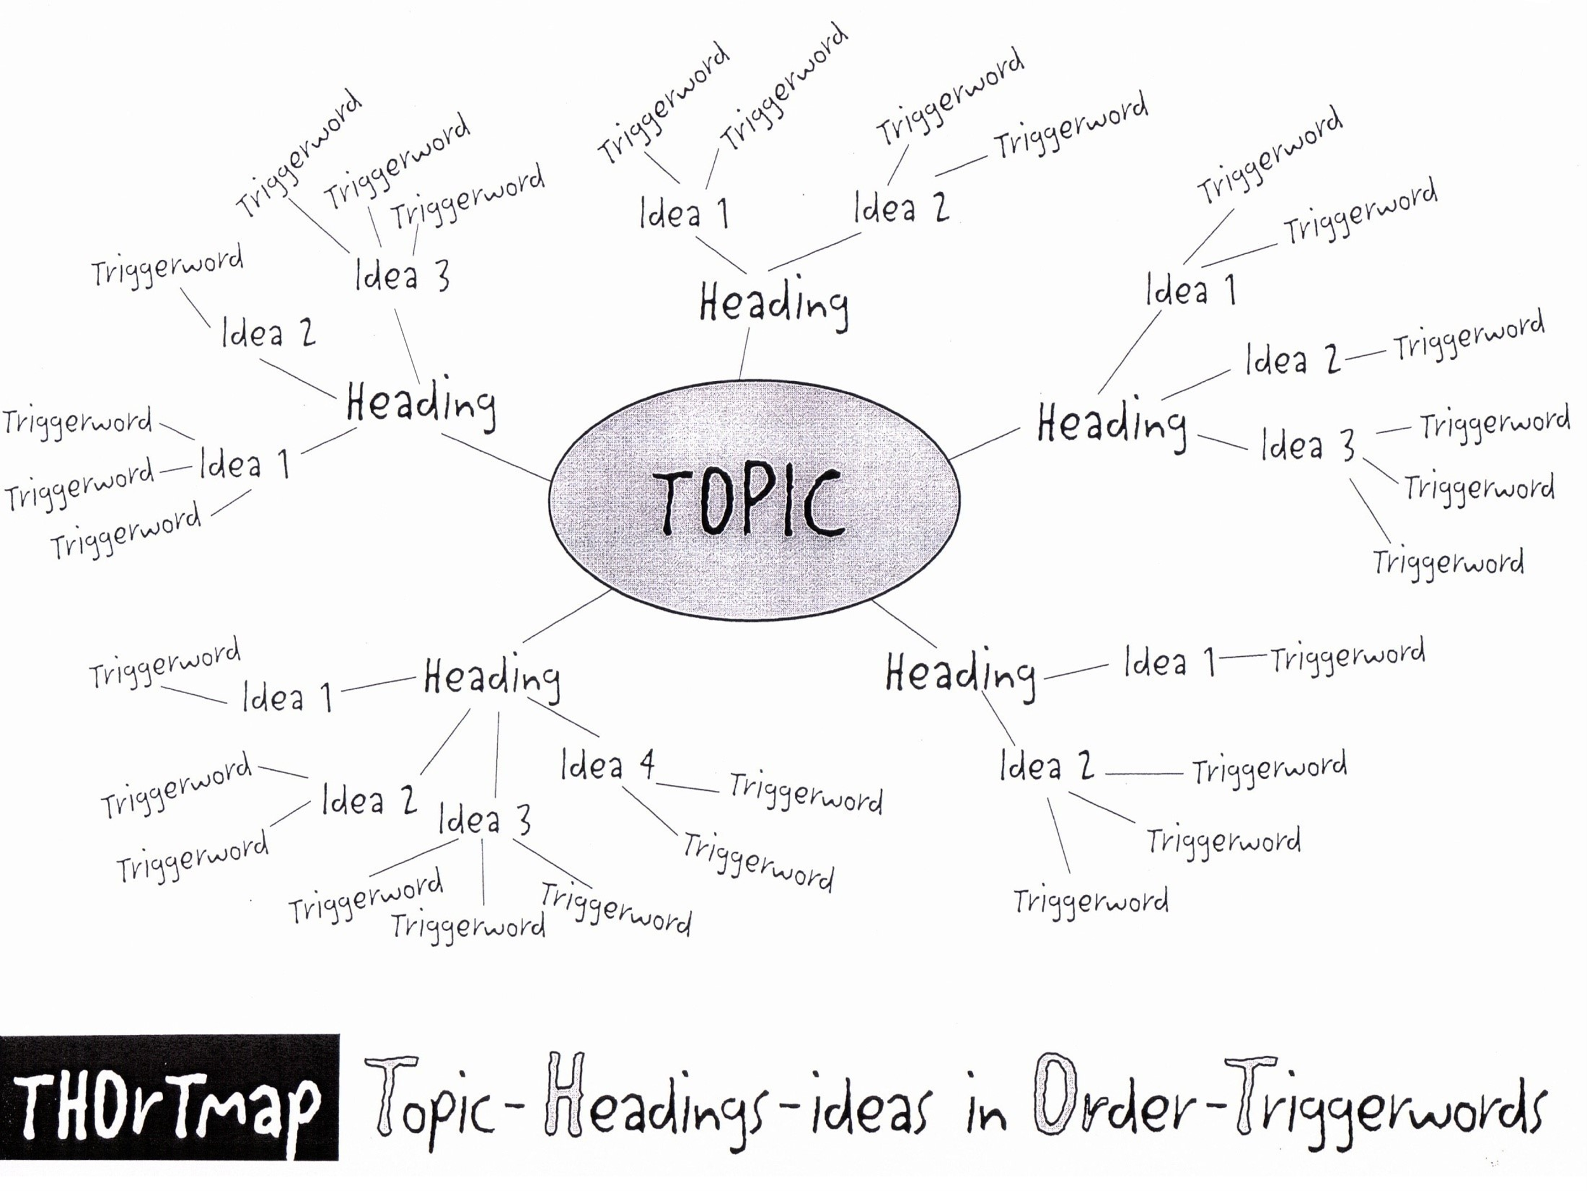

Use the Ultimate Summarising, Memorising and Note-Making Technique

Step 1 - Decide how many pages to summarise tonight. Skim read every page – only 5 seconds per page, make sure you look at every word.
Step 2 - Write the first main TOPIC in the middle of a clean page (landscape). Add to it all the HEADINGS, as branches – a maximum of 5 Headings per THOrTmap.
Step 3 - Back to the first page of the notes. Actively read the material now, search for the TRIGGERWORDS - and highlight them. Only one or two Triggerwords per sentence.
( LOOK Step )
Step 4 – Group the TRIGGERWORDS around key IDEAs and attach the Ideas to the Headings in Order.
( DO Step )
Step 5 – When you have finished, add in colour and small pictures, diagrams, cartoons to maximise the sensory connections with the information.
Step 6 - Pick up your completed THOrTmap and out loud, turn your THOrTmap back into sentences, Explain it to yourself, in your own words.
( LISTEN Step )
Step 7 - For any parts you don't yet understand, go back to the book or the notes and pull out a few more words to add to your THOrTmap. Explain that part to yourself again.
Step 8 – After a 10 minute break, look at your THOrTmap again and out loud, turn your THOrTmap back into sentences. Explain it to yourself, in your own words. If there are still parts you don’t remember or understand repeat Step 7.
( 10 Min Review )
Step 9 – Within 24 hours look at your THOrTmap again and explain it to yourself again, in your own words. If necessary repeat Step 7.
( 1 Day Review )
Step10 – Do another review the same as Step 9 after one week.
( 1 Week Review )
Step 11 - Do another review the same as Step 10 after one month.
( 1 Month Review )
Step 12 - Find an old exam question on the topic you have studied and do it without referring back to your notes. Check your answer with your notes
( Apply Step )
Step 13 – Keep a record of which study techniques work best in which subjects - for you. Where, when, how, with whom, using what resources. This is your own personal way of learning. Do more of what helps, less of what doesn’t help.
( Reflect Step )

Do you show your students how to learn?
- As an academic role model do you demonstrate for students to copy:
  - a willingness to challenge yourself and constantly learn new things?
  - the habit of admitting to and learning from all your mistakes?
  - the connection between active learning and success?
    - what does that take?

Practicing Courage:
My courage strategy is …

Thank you for your participation.
Best wishes,
Lance King

Appendix 1:
Kazakhstan National Curriculum Categories of ATL Skills | ATL Skills - Sub-Categories
COMMUNICATION SKILLS | - Language skills
 | - Social Skills
PROBLEM SOLVING and DECISION MAKING | - Organization Skills
 | - Decision Making Skills
TEAMWORK and INDIVIDUAL WORK SKILLS | - Metacognitive Skills
 | - Character Skills
 | - Group Skills
 | - Study Skills
RESEARCH SKILLS | - Research Skills
 | - Media Skills
ICT SKILLS | - Computational Thinking Skills
CRITICAL THINKING SKILLS | - Critical Thinking Skills
CREATIVE APPLICATION OF KNOWLEDGE | - Idea generation Skills
 | - Adaptive thinking Skills

TABLE OF CONTENTS ALL STRANDS

Kazakhstan National ATL Skills
Curriculum

COMMUNICATION SKILLS
1. Language skills
1.1 Feedback
1.2 Intercultural Understanding
1.3 Writing for Different Purposes
1.4 Reading Critically
1.5 Reading for Variety
1.6 Asking Good Questions
1.7 Symbols
1.8 Paraphrasing
1.9 Scientific Writing
1.10 Business Writing

2. Social skills
2.1 Social Media
2.2 Social Action
2.3 Wants, Needs and Rights
2.4 Leadership
2.5 Social Media Identity
2.6 Social Media Security

PROBLEM SOLVING and DECISION MAKING
3. Organization skills
3.1 Organizing Equipment
3.2 Organizing Files
3.3 Using Technology
3.4 Achieving Goals
3.5 Managing Deadlines
3.6 Time and Task Management
3.7 Exam Study Timetabling
3.8 Examination technique

4. Decision Making Skills
4.1 Inferences and Conclusions
4.2 Formulating Arguments
4.3 Identify Different Points of View
4.4 Evaluate Sources for Bias
4.5 Syllogisms, Logic and Conclusions
4.6 Develop Evidence-Based Arguments
4.7 Hard and Easy Choices

TEAMWORK and INDIVIDUAL WORK SKILLS
5. Metacognitive Skills
5.1 Reflecting on Content
5.2 Reflecting on Understanding
5.3 Reflecting on Learning Strategies
5.4 Self-Assess Learning Skill Development
5.5 Improve Performance
5.6 Reflective Journaling

6. Character Skills
6.1 Concentration and Mindfulness
6.2 Evaluating Risk
6.3 Persistence and Perseverance
6.4 Impulsiveness and Anger
6.5 Dealing with Pressure and Stress
6.6 Self-Motivation
6.7 Resilience
6.8 Failing Well
6.9 Values and Virtues
6.10 Courage

7. Group skills
7.1 Empathy
7.2 Negotiation
7.3 Taking Responsibility
7.4 Delegation
7.5 Fairness and Equity
7.6 Building Consensus
7.7 Resolving Conflict
7.8 Digital Collaboration
7.9 Teams
7.10 Leadership
7.11 People Management

8. Study Skills
8.1 Remembering Well
8.2 Your Best Ways to Learn
8.3 Helping others succeed
8.5 Skim Reading
8.6 Speedreading
8.7 Choosing Writing Organizers
8.8 Writing Essays, Scientific and Business Reports
8.9 Making Notes from Text
8.10 Making Notes from Presentations

RESEARCH SKILLS
9. Research Skills
9.1 Organize and Store Information
9.2 Develop a Research Question
9.3 Build a Search Strategy
9.4 Effective Digital Searching
9.5 Identify Sources
9.6 Link Research Tasks and Tools
9.7 Evaluate Sources of Evidence
9.8 Use Feedback to Evaluate Research
9.9 Ethical Research
9.10 IP rights, Academic Honesty and Referencing

10. Media skills
10.1 Non-Verbal Communication
10.2 Creating Presentations
10.3 Media Choices
10.4 Media Formats
10.5 Multi-media communication
10.6 Media Impact and Ethics

ICT SKILLS
11. Computational Thinking Skills
11.1 Decomposition
11.2 Pattern Recognition
11.3 Abstraction
11.4 Algorithmic thinking
11.5 Solve Problems using Computational Thinking

CRITICAL THINKING SKILLS
12. Critical Thinking Skills
12.1 Observing
12.2 Evaluating Assumptions
12.3 Data Analysis
12.4 Brainstorming
12.5 Visual Thinking
12.6 Consider Multiple Perspectives
12.7 Implications and Inferences
12.8 Correlation and Causality
12.9 Applications and Implications
12.10 Solve Problems - Think Globally, Act Locally

CREATIVE APPLICATION OF KNOWLEDGE
13. Idea Generation Skills
13.1 Impossible Solutions
13.2 Connections and Ideas
13.3 Guesses
13.4 Original Works
13.5 Metaphorical Thinking
13.6 100 Uses

14. Adaptive Thinking Skills
14.1 Creation through Imitation
14.2 Improvements
14.3 Flexible Thinking
14.4 Connections and Extensions
14.5 Form and Function

