ATL SKILLS FOR A POST-COVID DIGITAL WORLD -

Metacognitive skills – reflection, thinking about thinking, learning about learning
- Metacognitive Knowledge – students noticing and learning how they are learning - the thinking and learning strategies, techniques and skills they use to achieve successful learning
- Metacognitive Performance – students using that knowledge to improve their learning performance, change ineffective strategies, try new techniques, learn new skills
  - The key to metacognition is noticing your own thinking

Developing Metacognitive Knowledge using Think-Alouds:
- The ‘Student’ – is working on the puzzle and is allowing all their internal dialogue to be audible, they are saying out loud every word and every thought that is coming into their mind
- The ‘Teacher’ - is not working on the puzzle, just listening carefully to the ‘student’ and encouraging them to keep continuously talking - by saying things like “keep talking, keep talking…” and by asking questions:
  - questions which ask the student what they are thinking, what are the difficulties they are having with the puzzle and how they are going to overcome them
  - questions which focus on the thinking process NOT on the solution to the puzzle
  - THE ‘TEACHER’ MUST NOT HELP THE ‘STUDENT’ FIND THE ANSWER

Developing metacognitive knowledge through reflection on process
- In those exercises, when you got ‘stuck’ -
  - describe to your partner what you said to yourself
  - describe what you imagined
  - describe what you did to move past a ‘stuck’ moment
- That is your problem-solving process for visual puzzles
- Teach it to your students

Developing students’ reflection on process using puzzles:
- Give your students puzzles to solve and ask them if they are aware of deliberately using any problem-solving strategy to solve puzzles
- Ask students who successfully solve problems to outline their thinking process – the questions they asked themselves, the logic they followed – share with all students, create a thinking strategies noticeboard
- See how many different thinking strategies your students can come up with

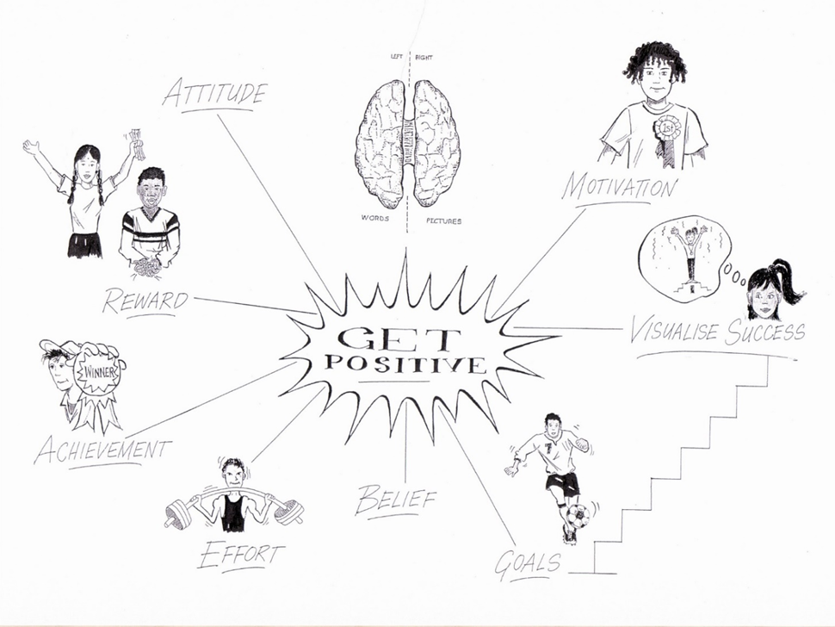
Ways of Thinking
Verbal | Non-Verbal
- words  - logic  - ‘one step at a time’ thinking  - self-talk  - analysing  - phonetic memory  - detail first | - pictures  - guesses  - ‘all at once’ thinking  - imagination  - synthesising  - visual memory  - big picture first
Turning those ideas into reality | Generating ideas that don’t yet exist
Good problem solving requires both ways of thinking

Patterns in Maths:
Use the number chart to find the pattern and then add some more numbers to the series:
1, 3, 5, 7, 11, 13 ……………………………………………………………………………………………………………
4, 22, 26, 34, 38 ……………………………………………………………………………………………………………
9, 33, 39, 51 …………………………………………………………………………………………………………………
5, 25, 55 ………………………………………………………………………………………………………………………
16, 20, 28, 32 ………………………………………………………………………………………………………………
12, 18, 30, 40 ………………………………………………………………………………………………………………
24, 36, 48, 60 ………………………………………………………………………………………………………………
What’s special about;
60? ………………………………………………………………………………………………………………………………
72? ………………………………………………………………………………………………………………………………

Using assessment of understanding to develop metacognitive skills:
- At the end of any unit of work
  - Have they achieved the content and process goals?
  - What is their evidence?
    - Is this really what you as a teacher need to know?
  - What don’t they understand yet?
  - What questions do they have?
- This turns assessment into metacognitive training – recognising gaps in knowledge and understanding.
- Teaching students how to notice what they don’t yet know is far more useful than having them prove what they do know

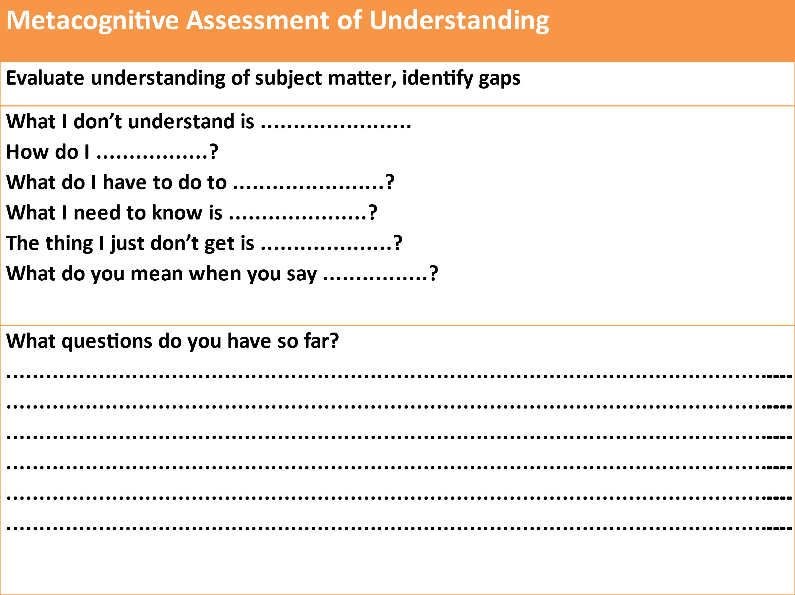

Assessing ATL skills:
- When your ATL programme is working well you will see:
- improvements in the efficiency and effectiveness of your students learning in all their normal subjects
- improvements in their performance in formative and summative assessments and all high-stakes exams, and
- improvements in in their ability to manage their own learning

Using ATL skills self-assessment to develop metacognition:
- Learning how to accurately self-assess your own work is a ATL skill in itself
  - get students to self-assess their own ATL skill development
    - for this you first need Mastery statements for all ATL skills
    - then you need one development rubric to cover all ATL skills

ATL skill Mastery
- ‘Mastery’ is the highest standard of independent use of each ATL skill strand that you would expect to see by the end of the PYP - with no teacher support:
- “By the time our students finish the PYP they will be able to ………………………...”
- Take each ATL skill strand you are wanting to develop and create a mastery statement for that skill

Rubric for all ATL skill development and assessment:
Competence |  |  | Practice |  |  |  | Mastery
Watching | Copying | Starting |  | Practising | Getting better | Got it! | Teaching
I know what the use of the skill looks like when others are using it | I can copy someone else using the skill | I am starting to use the skill by myself |  | I am using the skill by myself in familiar situations | I am getting better at using the skill in unfamiliar situations | I am able to use the learning skill whenever I need to | I use the skill without needing to think it through first
I can break the skill down into steps | I use the skill one step at a time | I am still conscious of using the skill one step at a time |  | I am starting to put all the steps of the skill together | I can usually use the skill without referring to the way that I have done it in the past. | I can confidently use the skill without referring to the way that I have done it before | I am capable of teaching other students how to use the skill
When I try to use the skill myself I make lots of mistakes and ask lots of questions | I still make mistakes and ask for help but I am getting better at correcting my own mistakes | I can correct my mistakes with some help |  | I can correct my own mistakes | Any mistakes I make I can quickly correct | I can usually correct any mistakes automatically | I correct any mistakes I make automatically
I need lots of help to use the skill | I can use the skill in familiar situations with some help | I still need help to use the skill sometimes |  | I don’t need help to use the skill in familiar situations anymore | I still need help to use the skill in unfamiliar situations sometimes | I hardly ever need help to use the skill anymore | I can use the skill in unfamiliar situations without any help from anyone else

Student self-assessment of ATL skill development:
Student Self-Assessment of ATL Skill Proficiency
ATL Skill | Competence |  | Practice |  |  |  | Mastery
 | Watching | Copying | Starting | Practising | Getting better | Got it! | Teaching

Developing self-assessment as an ATL skill in itself:
- Use self-assessment to teach students how to accurately judge the quality of their own output - the most important ATL skill for all future education and careers
- When assessing students’ subject work try:
  - asking them to include a self-assessment on what they did well and what they could improve on
  - give them feedback on both their subject work and the quality of their self-assessment

Three valid forms of ATL skills assessment:
- Student self-assessment of ATL skills proficiency completed pre~ and regularly post~ training
- Teacher reporting on ATL skills in reports – qualitative not quantitative
- Designing subject-based assessments so that generating the answers needed requires the use of specific ATL skills at the appropriate level of proficiency

