A Brief History of Curricula and ‘Schooling:

Although learning has been going in human beings since we were shrew moles 150 million years ago, the earliest known evidence of deliberate teaching has been found in modern day Iraq dating back to the Early Dynastic period (circa 2900-2350 BCE) of Mesopotamian history. The evidence is in the form of cuneiform tablets used as records of writing, created by both teachers and students. They clearly show writing exercises and mathematical problems being completed by students and lexical lists and literary texts being used by teachers.

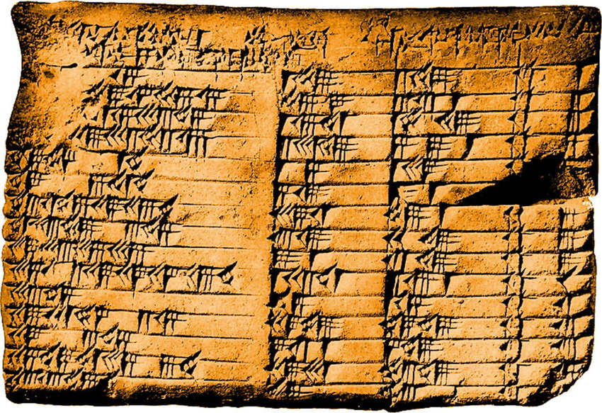

During this period (c. 3500-3000 BCE) formal education emerged in both Mesopotamia and Egypt in the form of specialized schools founded primarily to teach subjects like reading, writing, mathematics, and religious studies to scribes. Scribes were highly valued for their ability to read, write, and keep records, which were essential for the functioning of society, including administration, trade, and religious practices. The education of scribes was typically reserved for the elite, and these individuals played key roles in Mesopotamian and Egyptian societies.

By the Classical period of ancient Greece (5th-4th centuries BCE), there had been a notable shift in the concept of education. The Greeks introduced the idea of a more well-rounded and general education, which was seen as beneficial for all citizens, not just an advantage for the elite. This shift was influenced by the philosophical and cultural developments of the time:
- Plato, in his work "The Republic," advocated for a system of education that aimed to develop the virtues and talents of all citizens. He proposed a curriculum that included subjects like mathematics, philosophy, physical education, and music.
- Aristotle, in his work "Politics," stressed the importance of education for the moral and intellectual development of citizens. He discussed the merits of a broader education that extended beyond technical skills.
- The establishment of the Academy in Athens by Plato and the Lyceum by Aristotle marked the emergence of educational institutions that offered a more comprehensive education to a wider range of students.
The taught curriculum at this time included mathematics, philosophy, rhetoric, music, and physical education.

While these developments in ancient Greece marked a transition toward a more inclusive and generalized concept of education, it's important to note that access to education was still limited to the free male citizens of Athens and other Greek city-states. Education for women, slaves, and non-citizens remained largely excluded from these formal systems. Nonetheless, the Greek approach to education laid the foundation for later educational philosophies and systems that aimed to provide a broader and more accessible education to a wider population.

Ancient India's education system is rooted in the Vedic tradition (c. 1500-500 BCE), with the earliest texts known as the Vedas. Education was initially oral and focused on the transmission of religious and philosophical knowledge. Students learned the Vedas, sacred hymns, and rituals under the guidance of gurus (teachers).

In China the oldest evidence of education through writing is the Oracle bone script (c. 14th century BCE) found on oracle bones and turtle shells used for divination during the Shang Dynasty. These inscriptions include characters that suggest an early form of writing and the training of scribes. While not formal education in the modern sense, the emergence of written language and the role of scribes suggest an educational component. Simila writing is also seen in inscriptions on bronze vessels from the Western Zhou Dynasty (c. 12th century BCE).

The philosopher Confucius (551-479 BCE) is often associated with the development of education in ancient China. His teachings emphasized moral values, ethics, and the importance of education in which literature, history, and classical texts, played a significant role. This system aimed to prepare individuals, particularly the elite, for civil service positions and have had a profound influence on Chinese education for centuries. The Confucian curriculum focused on the "Six Arts," which included rituals, music, archery, charioteering, calligraphy, and mathematics.

By the 6th century BCE the Gurukul system had become an integral part of ancient Indian education. Students lived with their guru in a hermitage (ashram) and received holistic education, including subjects like mathematics, astronomy, warfare, philosophy, medicine, and literature. The Gurukul system emphasized teacher-student relationships and holistic education.

By the 1st C BCE on the European content education had changed somewhat to follow almost a Confucian path and in the Roman Empire had evolved to focus primarily on preparing children from wealthy families for careers in law, government, and the military. The curriculum included Latin and Greek literature, rhetoric, and mathematics.

In China starting in the Sui Dynasty (late 6th century CE) and formalized during the Tang Dynasty (7th century CE), the imperial examination system in China became a cornerstone of Chinese education. This system tested candidates on their knowledge of Confucian classics and served as a means for selecting government officials. It was a precursor to modern standardized testing and marked the beginning of assessment driven education.

Ancient Japan had a system of education influenced by Chinese models with Buddhist temples and Shinto shrines often serving as centres of learning. During the Kofun Period (c. 3rd-7th centuries CE) there is evidence of education, including the use of Chinese characters in inscriptions and the training of individuals in various skills.

The Heian Period (c. 8th-12th centuries CE) saw the emergence of the aristocratic court culture and the establishment of the Imperial Academy (Daigaku-ryo). This period laid the foundation for classical Japanese education.

Later, during the Edo period (17th-19th centuries) the Tokugawa Shogunate implemented policies to promote education, including the establishment of terakoya (temple schools) and han schools (feudal domain schools). This period saw increased literacy and access to education.

During the Middle Ages in Europe and the Middle East (~600 – 1400), education was primarily provided by monastic schools and the curriculum was centred around religious studies and the rote memorisation of religious dogma. Monks and clerics were the primary educators and (male) students were taught (depending on their country) Latin, Greek, the Bible, the Koran and other religious texts, theology and philosophy. The focus of education during this time was on preparing young men for a life of religious service, rather than secular careers.

The Renaissance period (~1400 – 1600) saw a shift in the focus of education, as scholars began to emphasize the study of the natural world and humanism. The curriculum during this time included the study of mathematics, science, and literature, as well as classical languages and philosophy. The emphasis on the study of the natural world during the Renaissance laid the groundwork for modern science and mathematics education.

In late Imperial China (~1600 – 1800) the curriculum continued to emphasize Confucian teachings, with a focus on classical literature, poetry, and moral cultivation. However, practical subjects such as mathematics, sciences, and foreign languages gained some recognition.

The Enlightenment era and the Industrial Revolution in Europe (~1600 – 1800) saw a further shift in the focus of education, as scholars began to emphasize reason and logic over religion. Educational philosophers like John Locke and Jean-Jacques Rousseau influenced the development of modern educational theories. Formalized school systems began to emerge, and curricula expanded to encompass mathematics, science, philosophy, and literature, as well as history, geography and the natural sciences The emphasis on reason and logic during the Enlightenment led to the development of critical thinking skills, which are still valued in modern education.

In the 19th century, the widespread adoption of compulsory education in the West led to the development of public education systems across Europe and the USA and the standardization of school curricula. The focus of education during this time was on providing young people (mostly male) with the skills they needed to succeed in industrialized societies, such as reading, writing, and arithmetic, as well as technical skills like machine operation and assembly line work. This led to the development of vocational education programs, which provided students with job-specific skills and training.

The late 19th and early 20th centuries saw schooling in the West become both more standardized and more broad with curricula designed to provide a common set of skills and knowledge to all students and subjects like literature, mathematics, science, and physical education became staples in the curriculum.

In China during the Republican Era following the end of imperial rule (1912-1949), modern educational reforms were introduced. The curriculum was broadened to include subjects like science, humanities, and foreign languages. Efforts were made to incorporate Western knowledge and modernize education.

With the establishment of the People’s Republic of China (1949-present), the Chinese curriculum underwent further transformations. The emphasis shifted towards ideological education aligned with Marxism-Leninism, Mao Zedong Thought, and later Deng Xiaoping Theory. Math, science, and technical subjects were also emphasized to support industrialization and modernization efforts.

In the latter half of the 20th century, the focus of education in most Western and Eastern countries shifted again, this time towards preparing students for college and careers in an increasingly globalized world. The curriculum during this time included the study of traditional subjects, as well as new subjects like computer science, business, and foreign languages. The emphasis on global education during this time led to the development of programs that sought to provide students with the skills and knowledge they needed to succeed in an increasingly interconnected world.

The year 2000 saw the introduction of the Programme for International Student Assessment (PISA), an internationally recognized assessment conducted by the Organisation for Economic Co-operation and Development (OECD). PISA was designed to evaluate and compare the performance of 15-year-old students in reading, mathematics, and science literacy across different countries. Its goal was to provide policymakers with valuable data to assess the effectiveness of their education systems and identify areas for improvement.

The release of the first PISA results in 2000 sparked a global conversation about the state of education and the need for educational reform. The findings revealed disparities in student performance and highlighted the need in every country to shift focus from rote memorization and subject-specific knowledge to critical thinking, problem-solving, and practical application of knowledge. Post-2000 many countries started to incorporate competencies such as critical thinking, collaboration, creativity, digital and media literacy into their curricula, they started to integrate cross-curricular approaches and inquiry-based learning methods, curricula started to address social-emotional learning and mental health support and the need to enable students to navigate and critically evaluate information in the digital age.

In recent decades, the curriculum has continued to evolve. There is a growing emphasis on STEM (science, technology, engineering, and mathematics) education in most parts of the world, as well as a recognition of the importance of all the ‘21st-C’ skills. Some education systems have introduced more personalized learning approaches and a greater emphasis on vocational and technical education.

If you check the taught curriculum of your children’s school I am confident you will find it organised around academic subject disciplines like Maths, Arts, Sciences, Social Studies, Languages, Physical Education, Biology, Chemistry, Physics, Accounting, Business Studies, Economics, Geography, History etc. The subjects have changed with the times but the idea of teaching ‘subjects’ has not changed. In the same place where you find your school’s curriculum you will probably also see lots of rhetoric about “…providing a challenging, varied and dynamic learning environment for all students” and words like “…inquiry learning environment” and “…authentic assessment”. But it is a very rare school that also includes a curriculum of the thinking and learning and information processing skills that all students need in order to be able to learn all their subjects however they are taught.

This set of essential ‘21st-C’ skills for successful learning at school and beyond can be organised many ways. I tend to group these skills into the following fourteen categories or ‘process disciplines’:
- Organization Skills
- Study Skills
- Character Skills
- Metacognitive Skills
- Language Skills
- Media Skills
- Group Skills
- Social Skills
- Research Skills
- Critical Thinking Skills
- Computational Thinking Skills
- Decision Making Skills
- Idea Generation Skills
- Adaptive Thinking Skills

These are the thinking, learning and information processing skills that need to be directly taught to our children to prepare them well for their future in a post-Covid, digital, AI enhanced world.
If your school does not have these process disciplines in their curriculum and you are concerned that your child will be seriously disadvantaged by not being directly taught all these process skills then this book will provide you with the answers you need.
Not only will this book show you exactly what your children need to learn to maximise their advantage it will also show you the best resources available for your children to learn all these skills for themselves and develop into fully capable self-managed learners.

