DEVELOPING METACOGNITION THROUGH REFLECTION

At the MYP level students will be asked to engage in concept based inquiry learning which will include a regular refection phase where they will reflect on the three key aspects of metacognition:
- the subject matter they have explored and learned – from the point of view of understanding and retention of content
- the ATL skills they have been focused on and their demonstrable level of competence with each skill
- the particular learning strategies or techniques teachers use or they employ themselves in learning the subject matter and the impact of these strategies on their learning success

This level of reflective inquiry learning uses the same principles as exemplified in the 3 phase PYP inquiry learning cycle but adds in one more age appropriate step to raise the cognitive level and develop into the full experiential learning cycle

observing and reflecting

thinking and conceptual understanding

questionning and planning

taking action

reflection

inquiry

action

Inquiry Learning Cycle Reflective Learning Cycle

PYP MYP + DP

The Reflective Learning Cycle can be used as a pedagogical framework for inquiry lesson design as well as a reflective framework for developing full metacognitive awareness within the student of both of both product and process.

Step one is to become familiar with the use of the Reflective Learning Cycle through the analysis of a previous learning experience. Once familiar with all the steps of the cycle students can then use the same analytical system to plan and implement a strategic approach to a new learning situation.

UNIT 1 - Developing Metacognitive Awareness
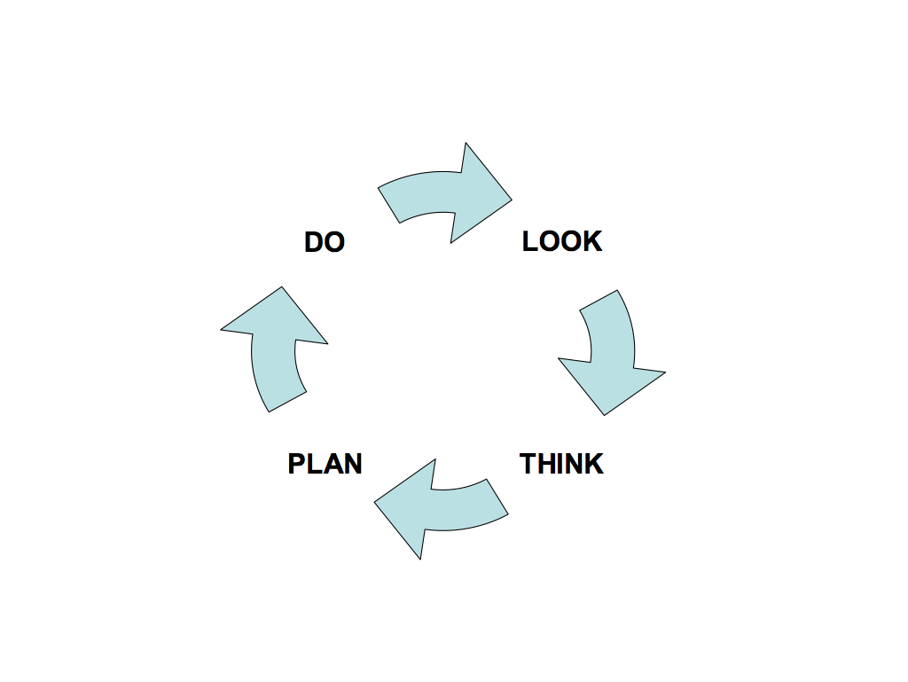

ASSIGNMENT 1
Complete questions 1, 2, 3, 4, 5, 6, 7 & 8 as Assignment 1 on separate paper and hand in with this booklet

Question 1:
Draw a diagram of the four step experiential learning cycle.

Question 2 – Choose a Topic:
Choose a previous learning experience which can then be analysed using this cycle. To do this what you have to do is to choose a situation or experience from your own life where you learned something new by doing it – by having the experience. In other words you need to choose something that at one time you couldn’t do very well but something that you applied yourself to and you learned gradually and got better and better at.
Some examples might be learning:
- to ride a bike, a skateboard, a horse
- to surf, skate, swim, snow ski, water ski,
- to use a tool like a wood chisel, a food processor, a welder, a skill saw, a sewing machine
- to operate a computer, a video camera, a digital camera, a microscope, specific software packages
- to play a musical instrument, a computer game, x-box or playstation game
- to draw, paint, sing, dance, act, juggle
- to play rugby, soccer, netball, basketball, water polo
- gymnastics, athletics, ballet
- to study well, to pass exams, to learn well
- how to get along with other people, make friends, be compassionate, caring, considerate
- how to start and run your own business

OK so now you have to choose – complete the sentence:
a) the learning experience I am choosing to analyse is learning to………………..

In the next few questions you are going to analyse how you went about learning and improving your performance in this area. The questions are going to ask you details of the actions you took as if you were watching yourself perform them. You will have to use your imagination to see yourself learning this thing and improving your performance. The aim of this exercise is to get you familiar with breaking down performance improvement into distinct steps so that you can then apply this model to improving your own performance in any area you choose.

Question 3 – Pre-conditions:
Now you need to analyse how you were before you learned to do this thing you have chosen. To do this you need to describe the following (not necessarily in this order):
Before you learned how to do this thing….
- what skills did you already have in this area?
- why did you want to learn this thing, what was your motivation?
- what made you think that you would be able to do it?
- how did you feel about the possibility of being able to do it?
- what was your situation, what was going to happen to enable you to learn it?
- before you started learning it what was the level of commitment you had towards completing it – how determined were you?
- how easy or hard did you think it was going to be, how much effort did you think it would take?
- how long did you think it would take you to learn it?
- to what level were you planning to master this thing?
- what other things did you think you would be able to do once you had learned this new thing?

Question 4 – the LOOK step:
Think about when you were first learning how to do this thing – before you could do it well:
- describe how you did it before you could do it well - describe what you did, step by step.
- imagine you were someone else watching you do it then – describe what they would have seen if they were watching you before you could do it well

Question 5 – the THINK step:
From your experience described in Q.4:
- list the things that you noticed that you did which worked - which helped you improve, and
- list the things that you noticed that you did which didn’t work – which didn’t help you improve
- how did you feel when you were at this early stage of learning this thing?
- what did you notice that other people did that seemed to work?

Question 6 – the PLAN step:
Based on your thinking in Q.5 now:
- describe the changes you decided to make to improve your performance next time
- describe what the different actions you decided to do were – step by step
- how did you expect the next experience to go?

Question 7 – the DO step:
- describe what actually happened next time?
- how did you measure your improvement?
- how did you feel about that improvement – how did it effect your motivation for the future and your expectations of yourself
- what did you decide to do from then on
- describe how your actual experience of learning this thing matched up with your expectations described in Q.3

Question 8
Having considered your learning in this situation to be a cycle of four steps
do look think plan do look think plan do …….
list three other things that you have learned where this same type of learning – experiential learning – occurred.

ASSIGNMENT 2
Complete questions 9, 10, 11, 12, 13, 14, 15, 16, 17, 18 & 19 as Assignment 2 on separate paper and hand in with this booklet

Question 9.
Now you need to apply this same four step model to improving your present performance in some area DIFFERENT TO THAT CHOSEN FOR ASSIGNMENT 1. You now need to choose something that you do at present that you would like to improve your performance in. It could be in an academic area eg. to achieve better assignment results, test results, exam results, or a skill area eg. to play guitar better, to dance or sing better, or a sports area eg. to play better netball, rugby, soccer or something else in an area of your own choosing. And you also need to decide on the level of performance improvement you want to aim for – how will you measure the improvement – be very specific.
On a separate page as the first answer of Assignment 2 complete the following three sentences:
a) I would like to improve my performance in.……..
b) The specific improvement that I wish to achieve is……….
c) I will know I have achieved it when………

Question 10 – LOOK step part 1:
Describe your present ability in this field:
- what can you do easily?
- what is more difficult for you?
- what aren’t you able to do yet?

Question 11 – LOOK step part 2:
Imagine you are someone else watching you practicing this thing that you want to improve, at the moment:
- describe accurately and in detail exactly how you do it at present
- describe exactly what happens when you get it wrong, when you do it poorly or badly
- describe what actions you take, what actually happens, step by step.

Question 12 – THINK step part 1:
Find someone whose performance in your chosen field is as good as or better than your desired performance and ask them to describe in detail what they do to achieve their performance and what they think you could do to improve, then describe:
- who they are
- what they do to achieve their performance
- what they think you should do to improve

Question 13 –THINK step part 2:
From textbooks or from the net or by using other reference sources find out what is theoretically the best way to achieve higher performance in your field:
- quote all the references of where you get your material
- describe the way to achieve good performance that is recommended in your references
Question 14 – THINK step part 3:
Compare your performance as described in Q.10 & Q.11 with the two approaches described here (Q.12 & Q.13) and:
- identify the areas of difference – where you are doing things differently to what is recommended
- identify areas where your performance could be changed to achieve improvement
- describe these areas of possible improvement.

Question 15 –PLAN step:
Make a plan to improve your own performance, make sure that the plan states exactly:
- what you are going to do – in detail
- when you are going to do it
- how you will know you have done each step successfully
- how you will measure your performance improvement overall.

Question 16 – DO step.
Now do it!
- describe the implementation of your plan from Q.15, include dates and times
- describe exactly what you actually did – describe in detail all actions taken, step by step
- gather evidence of your implementation of your performance improvement strategy to give to the Assessor (notes from people watching, coaches, teachers, photos, score cards etc. – you must have some evidence)

Question 17.
- describe any changes to performance against goals from Q.9 b & c and indicators from Q.15 c & d
- gather evidence to give to the Assessor of actual performance change (notes from people watching, coaches, teachers, test results, photos, score cards etc. -you must have some evidence )

Question 18.
Have you achieved the desired performance improvement?
If not go back to Q.12 and repeat the process looking for different changes you can make to improve your performance. Answer each question again and refine your process until you reach the performance improvement you desire.

Question 19.
Describe how you felt this process worked and how your motivation is now for further improvements in this field.

Step 2 is to start using reflection to check on understanding and retention of subject matter.

UNIT 2 – The Metacognitive Approach to Subject Matter Retention and Understanding

Understanding and retention of content are important dynamics of the school learning experience most often assessed through tests and exams. If content review is carried out by students on a regular basis understanding and retention of subject matter increases significantly.

Information processed in class has little chance of retention if it is only worked through in the classroom situation and not gone over again on a schedule designed to move it into long term memory.

In order to get information retention up to the 80 – 90% level it is necessary to put in place regular reviews of the key points of information covered in lessons (first discovered by Hermann Ebbinghaus 1850-1909 the creator of the ‘learning curve’ called the Spacing Effect - reviewed by Crowder 1976; Greene, 1989).

The timing of these reviews has been found by research into brain activity and memory
be most effective if they occur on the following schedule:
- after 10 minutes
- 1 day
- 1 week and
- 1 month

Teachers can utilize this sequence of review to increase retention of content by putting in place regular reviews as follows:

- Start every lesson with a closed book preview of the previous lesson:
This can be achieved most simply at the start of every lesson by waiting until all the students are seated and settled and then asking them
“What did we do last time?”
You are asking the students to tell you one thing each that they remember from your previous lesson whether it was the previous day or several days ago.
This achieves two key things:
- It causes the students to refresh their memory of the previous lesson which helps them to focus in on your subject rather than have their mind still focused on their own previous lesson
- It brings all students up to speed with the topic you are covering in class, those that answer the initial question and those that listen as well, so they all are then ready to move on in that topic
Another way to get this review working well is to make the initial question a short 5 minute test, maybe 10 multichoice or 5 short answer questions only on material covered in the previous lesson, the answers to which are then self assessed and minor rewards given to those who get all correct answers.
At this point the teacher can also ask:
“Has anyone got a question about our previous lesson? Anything you did not understand that you would like me to go over again?”
These questions are often best written down by the students and attended to by the teacher when time permits rather than addressed at this point – see point 3.

- Finish every lesson with a closed book review of that lesson:
This requires a teacher to finish the lesson 5 minutes before the bell, ask the students to close their books and then ask
“What did we just do?”
You are then looking to draw from the student all the key points covered in the lesson. This can be done randomly or in a more structured way by the saying:
“I want each of you to think of one thing you have learned in this lesson, I want you to put your hand up and tell me, I am going to ask every person for one thing and it must be different from what anyone else has already said”
This gets instant engagement especially if you add the proviso that
“When I have got one thing from every person then you will be able to go to your break (or your next class)”

This review achieves instant review of all the key points covered in the lesson which starts the process of moving information into long term memory.

One thing to avoid. Do not review a lesson by talking through or writing up the key points covered in the lesson yourself. Then the only brain engaged in the room is yours, they students are all just waiting to get out. You must draw the information from the students themselves, then they will all be engaged.

- Every night use homework to get students to check understandings and start making summaries of subject matter
If retention and understanding of schoolwork are important dynamics for you as a teacher then homework needs to be designed to consolidate learning by reviewing understandings, finding any problems and further assimilating content into long term memory by making summaries of key points.

Homework every night needs to have two components relating to subject matter, making sure all students:
- read through all the notes they took that day at school, pull out the key ideas covered and make them into a summary of key points
- check their understanding of all the information covered that day and for any points not understood formulate a written question along the lines of:
- What I understand about this is ……. but what I don’t understand yet
is ……........
- How do you get from ............. to…..........….?
- How do I ……....…?
- What I have done so far is ……… but what do I have to do to ……......?
- What I need to know is …....……
- The bit that I just don’t get is ….....……
- What do you mean when you say ….....……?
These questions can then be handed in by students during the first review of each class and addressed by teachers at the appropriate time.

(There is also a note making technique that can be used in the classroom to make this type of ongoing summarising a structurally easy thing to implement – see Additional Information)

- At the end of each week have students create a summary of the content covered in that week – open book
This requires teachers to give some formal classroom time to the creation of summaries of key points. The justification for which is that making summaries increases the students’ retention of content and thus reduces re-teaching time, thus increasing learning efficiency and saving overall classroom time.

Once a week, maybe at the end of the week, in the last class of the week, ask students to get out the summaries they have been making each night during the week of your subject matter and take all the key points represented there and turn them into one summary of the key points for the whole week. This exercise is probably done best as a small-group exercise because different students will have emphasized different points in their summaries and they will gain better understandings and retention by working together. These type of summaries are best made as mindmaps or THOrTmaps and made as individual and colourful as possible. Each student needs to end up with their own summary of the weeks work.

- At the end of each month have them put their weekly summaries together into a one month summary
On the last Friday of the month after the students make their last weekly summary for the month in groups they then need to create a one month summary of all the key points covered in the last month.
There are two ways of doing this, students can do either or both:
- Paste all four weekly summaries onto one large A3 page and then draw visible connections between all the points summarised for the whole month
- Analyse all four weekly summaries for main ideas and re-draw the main ideas an a new meta-summary or summary of summaries, just focusing on the big ideas covered in the month and relating them together
Once all the one-month summaries are completed you can then go around and find the best one out of the whole class and maybe photocopy it and pin it on the wall (if you have a dedicated classroom) or put it in a clip folder (if you don’t).

If you keep this process up for the whole year, by the time you get to the end of the subject matter for the year you will have summaries of all the key points covered in your subject over the whole year available for students to look at and review in the lead up to any tests and exams.

-----------------------------------------------

Additional Information: Note Making technique to allow for nightly review:

If students are regularly required in your classroom to make their own notes from information presented by the teacher or from textbooks or internet resources then a structured approach to making those notes can be used to facilitate the one-day review.

First the students take a whole, normal clean page that they are intending to write notes on and:
- before they write their notes they draw a vertical line down the page about 1/3 of the way across the page in from the left side of the page
- then when they make their notes in class they only write their notes on the 2/3 side of the page
To facilitate engagement of all information processing parts of the brain they should make sure that they
- change the colour they are writing with each time the information they are writing changes to a new idea

They then end up with all of their notes written only on the 2/3 side of each page leaving the 1/3 side blank and all the ideas will be separated out from each other by virtue of being written in different colours.

Then, to facilitate the movement of information into long term memory:

- each night, for homework, they read through the notes they wrote that day in class, pull out the key points – the main ideas – and write them in as a summary in the column on the left.

All their notes then contain both the detailed information and the summaries of key points and turning those key point summaries once a week into weekly summaries becomes a simple process.

Step 3 is to look at the ATL skills employed each day and reflect on personal competence with each skill

UNIT 3 – The Metacognitive Approach to ATL Skills

The development of ATL Skills is an essential part of the new MYP and each student needs to be made aware by teachers of the ATL skills being practiced in every lesson. It is not intended however that ATL skills are assessed in any summative way or that students be judged as to their progress in the acquisition of each skill.

It is an important aspect of each student’s own developing metacognitive ability however that they are constantly self-assessing as to their own perceived competence in all the ATL skills.

Skill acquisition passes through 4 distinct phases (adapted from Dreyfus, 2004):

Observable Behaviours
Level 1  Novice  - observation | Level 2  Learner  - emulation | Level 3  Practitioner  - demonstration | Level 4  Expert  - self-regulation
Observes others performing tasks and using the skill  Gains an understanding of how the skill operates and what the distinguishing characteristics of the skill are  Gathers procedural information about the performance of the skill, asks questions to clarify procedure  High levels of scaffolding from teacher needed - explanations, training, structural support | Copies others performance of the skill  Works through the skill in a step by step fashion, seeks clarification for correctness of performance  Is very conscious of performing the skill with deliberation  Performs skill only with known content in known context  Medium level of scaffolding needed - correcting poor performance, answering questions | Can demonstrate the skill on demand  Flexibility of skill use in different contexts is developing  Can perform skill with unfamiliar content or in unfamiliar context  Minimal teacher scaffolding required – setting directions, goals, assessable outcomes | Can perform the skill without conscious awareness  Can perform skill with unfamiliar content in unfamiliar context  High levels of performance occur  No teacher scaffolding needed  Can teach others the skill

It is important that students become very familiar with this table and use the distinctions here to self-assess their ATL skill acquisition on a regular basis.
One way to achieve this is to make sure that a simplified version of this table is printed in each student’s homework diary. Then each night as part of normal homework each student needs to take the ATL skills that were made explicit by the teachers in each lesson during the day and self-assess as to their perceived own level of competence.

The aim of the exercise is to get all students up to the Self-Regulated (Expert) level in all the skills deemed important by the school or the department by the end of a specified time period. The self-regulation or mastery of any ATL skill is easily demonstrated by the student being assigned to teach another student who is at the Novice level how to perform the skill. If they are successful in teaching others then they can be said to be performing at the self-regulated level.

The important dynamic here is the student’s own awareness of the skills they are developing and their progress towards the Expert level. It is not important for the teacher to be involved in this process except to:
- decide as a school or department exactly which of the ATL skills they will be focusing on in any time period
- make clear to the students in every lesson the particular ATL skills being focused on in that lesson
- teach the skills directly to the students either in isolation or by using their own subject matter as the content to practice the skills on
- if deemed necessary by the department or school ask students to indicate to the teacher when they consider they have reached the self-regulated level of skill mastery and then to demonstrate their competence by teaching that skill to another student who is at the novice level for that skill

It should not be necessary for any teacher to get involved in the progress or development of any skills with students except to answer questions and provide procedural information or extra subject matter to practice skills on.

Each night students need to reflect back on the lessons they took that day, list the skills practiced that day and assess their own level of competence with each skill.

Teachers can help with this process by designing self report charts that students can use to keep a track of their own progress in acquiring ATL skills (simple example below). Well designed systems will not only help students to become more aware of their own learning skills competence they will also help a student build up the skill of self-assessment – a key metacognitive skill.

Each night put a tick in a box (and a date) showing where you think you are up to in gaining each of these particular skills
Skills to be focused on this month: | Novice  - observing others | Learner  - copying others | Practitioner  - demonstrating to others | Expert  - teaching others
Giving and receiving feedback
Respecting different opinions
Collecting, recording and verifying data
Identifying different points of view
Practicing focus and
concentration

Step 4 is to reflect on the learning strategies and techniques employed daily and consider them from the point of view of effectiveness and efficiency in helping reach the learning goals

UNIT 4 – The Metacognitive Approach to Learning
Strategy Use

Each day at school students are exposed to a range of learning methods employed by teachers in class and by themselves in any independent study. The third important aspect of metacognition involves the students reflecting on the learning strategies and techniques they are exposed to from the twin points of view of those that help them learn and understand and those that don’t. Analysis of this information in an ongoing fashion will then allow any individual student to build up a profile of themselves as a learner and enable them to calibrate their own most effective ways of learning. The results of which can then be used by the student to improve their learning performance in all their own independent study for tests and exams.

Each day as the third leg of the metacognitive reflection each student needs to recall one time that day when they noticed they were learning well and one time that day that they noticed they were not learning well. For each incidence they then need to remember what the particular teaching/learning strategy was which was being employed at the time. This can be achieved by students filling in on a regular basis tables like the following:

One time I noticed today that I was learning well was..... | The way in which I was being taught was..... | The way in which I was learning was..... | Who/what helped me to learn was.....

One time I noticed today that I was not learning well was..... | The way in which I was being taught was..... | The way in which I was trying to learn was..... | The reason I wasn’t learning well was.....

Each incident need not be within a classroom, it could be in private or independent study, it could be on the sports field or when they are pursuing their interests. The point of the exercise is to build up the metacognitive habit of noticing learning and teaching strategies while they are happening.

If this exercise is completed each day then by the end of one week there will be enough data for the student to start to draw some tentative conclusions about the conditions that appear to help them to learn well.

These conditions particular to them can then be assembled into a Learning Strategies Library which is simply a record of successful strategies employed which can be turned to when that student is engaged in independent study of their own when doing their homework or studying for tests and exams.

Analysis of learning experiences will not only yield information on strengths it will also provide data on weaknesses. This can be useful for the student to notice at which times or when exposed to what particular teaching methods they have a tendency to drift off or lose attention. They can then take on the challenge of learning how to focus and concentrate more deliberately and can test themselves with those instances which they know have not worked for them in the past. Learning how to learn deliberately and well when the conditions are against your own preferences and tendencies is a great achievement.

--------------------------------------

Step 5 – Overview of metacognition

The aim of all these exercises is to give a student practice in stepping outside the learning experience itself and viewing it as an observer. It is only by helping students to consider learning from the point of view of the processes involved that we enable them to become more effective and efficient learners.

Learning successfully is the outcome of the application of effective learning processes but all too often students become so immersed in the substance and subject matter of their learning that they lose sight of the processes employed.

It is hoped that by the application of these exercises students will gain an much greater appreciation of both the content and the processes of their own learning.

